**Experiment: 4**

**Objective:**

To solder and test and verify pulse width modulation (PWM) based receiver circuit (to receive IR signals from gantries connected to transmitter circuit) on printed circuit board (PCB).

**Component Used:**

|  |  |  |  |
| --- | --- | --- | --- |
| **Sr. No** | **Name of Components** | **Value** | **Specifications** |
| 1. | Resistor | 120K Ω | Carbon Resistor with 5% |
|  |  |  | Tolerance |
| 2. | Resistor | 100KΩ | Carbon Resistor with 5% |
|  |  |  | Tolerance |
| 3. | Resistor | 22 KΩ | Carbon Resistor with 5% |
|  |  |  | Tolerance |
| 4. | Resistor | 1 KΩ | Carbon Resistor with 5% |
|  |  |  | Tolerance |
| 5. | Capacitor | 0.1μF | Ceramic Capacitor |
| 6. | LM311D |  | Voltage Comparator |
| 7. | BPW41N |  | PIN diode |

**Theory:**

**Photodiode (BPW41N):** BPW41N is a high speed and high sensitive PIN photodiode

in a flat side view plastic package. The epoxy package itself is an IR filter, spectrally

matched to GaAs or GaAs on GaAlAs IR emitters (wavelength = 950 nm).The large active area combined with a flat case gives a high sensitivity at a wide viewing angle.

**Features:**

* Package type: leaded
* Package form: side view
* Dimensions (in mm): 5 x 4 x 6.8
* Radiant sensitive area (in mm2): 7.5
* High radiant sensitivity
* Daylight blocking filter matched with 940 nm emitters
* Fast response times
* Angle of half sensitivity: ϕ = ± 65°
* Compliant to RoHS Directive to 2002/95/EC and in accordance to WEEE 2002/96/EC

**Applications:** High speed photo detector

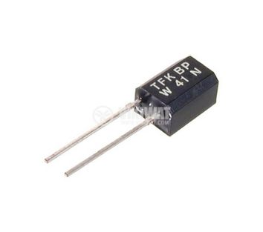

Photodiode (BPW41N)

**Schematic Diagram of Receiver circuit :**

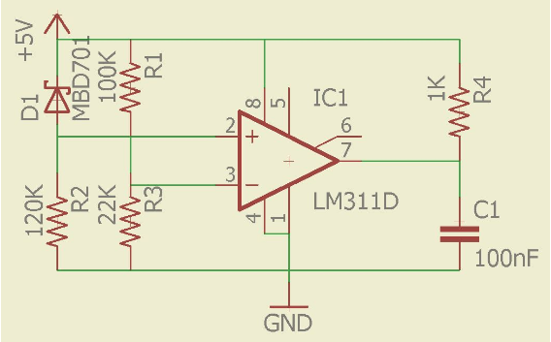

**Soldering of Receiver circuit on PCB:**

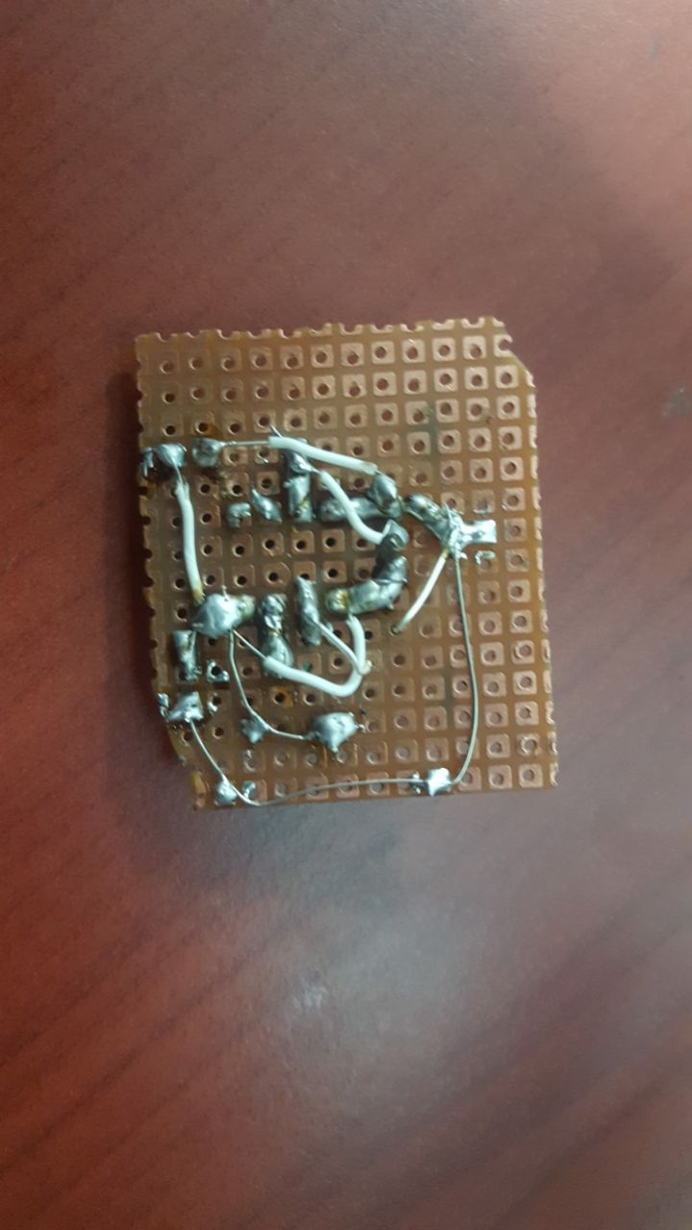

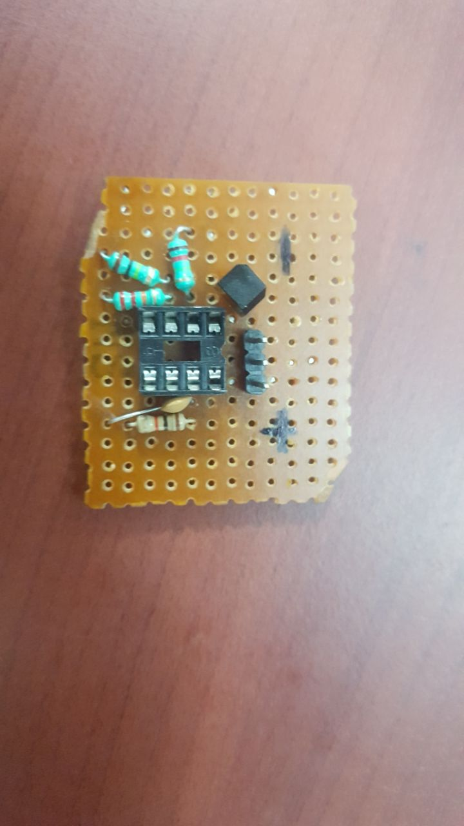

**Output waveform (Digital Storage Oscilloscope):**

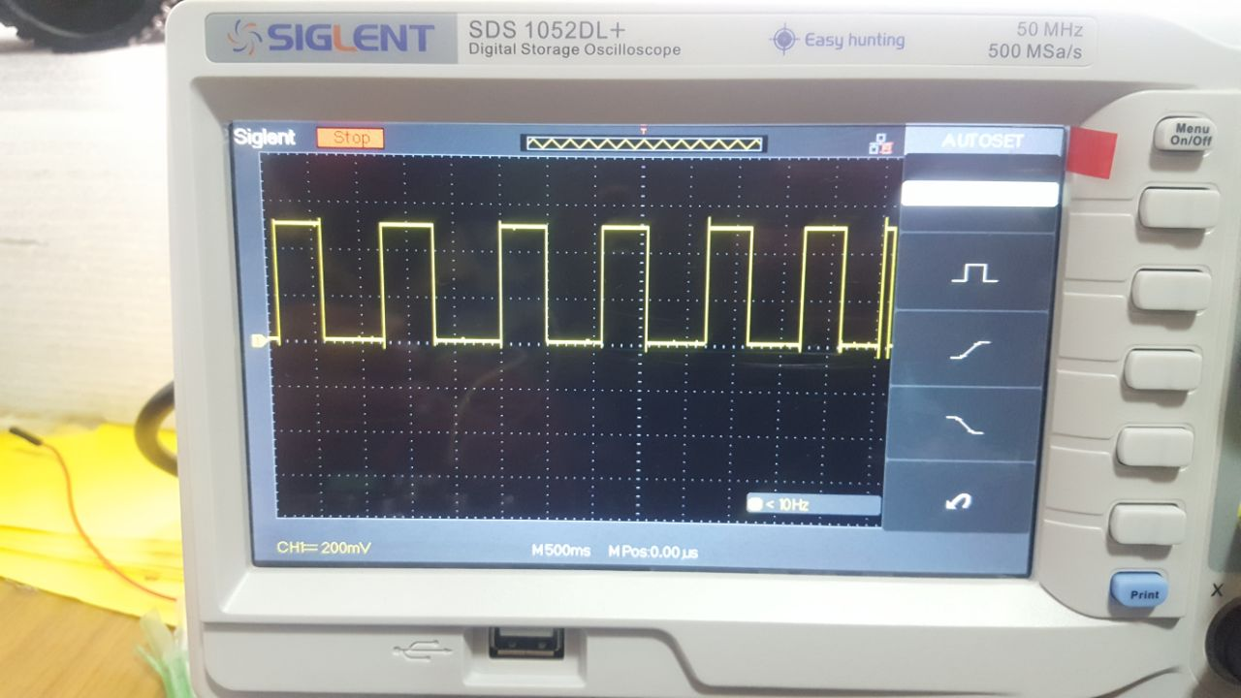

(Waveform(pulse) detected by Receiver circuit.)

**Discussion:**

In this experiment we have learnt about how to design receiver circuit which **we** have used in our buggy to receive signals coming from the transmitter circuit to sense any gantry coming on the pathway of the buggy.

While designing the circuit, the major issue that was faced was the short of connections with each other and these problems are resolved by solder carefully and check the connections after soldering

**Signature of Faculty member**